**COMSATS University Islamabad (CUI)**

**Project Proposal**

**for**

**Project Title**

(Valid title reflecting scope and objectives)

Version 1.0

***By***

**Student Name 1 CIIT/SP18-BCS-xxx/ISB**

**Student Name 2 CIIT/SP18-BCS-xxx/ISB**

***Supervisor*Supervisor Name**

***Co-Supervisor (if any)*Co-Supervisor Name**

***Bachelor of Science in Computer Science (20xx-20xx)***

**Table of Contents**

Abstract 1

1. Introduction 2

2. Problem Statement 2

3. Problem Solution/Objectives of the Proposed System 2

3.1 Objectives 2

4. Related System Analysis/Literature Review 3

5. Vision Statement 3

6. Scope 4

7. Modules 4

7.1 Module 1: Module Name 4

*Module 1: Order Meal* 4

*Module 2: Menu Operations* 4

8. System Limitations/Constraints 4

9. Data Gathering Approach 4

10. Tools and Technologies 5

11. Project Stakeholders and Roles 5

12. Module based Work Division 5

13. WBS and Gantt Chart 6

14. Mockups 6

15. References 6

16. Plagiarism Report 7

**Project Category: (**Select all the major domains of proposed project**)**

□ **A-**Desktop Application/Information System □ **B-**Web Application/Web Application based Information System □ **C-**Problem Solving and Artificial Intelligence □ **D-**Simulation and Modeling □ **E-**Smartphone Application

□ **F-**Smartphone Game □ **G-**Networks □ **H-**Image Processing□ Other (specify category) ________________

# Abstract

Write a one paragraph abstract keeping in view the following guideline:

**Rational:** Provide the reason why you are creating the proposed software/project. [1 sentence]

**Existing system:** Discuss the current state of the world. [2 sentences]

**Targeted challenges:** Problems/opportunities the proposed project is going to resolve. [2 sentences]

**Grey area**: Identify the gap that will be addressed by the proposed project. [1 sentence]

**Objectives**: Discuss the goals that the proposed project is going to achieve. [3 sentences]

**Significance of this project**: Discuss the key benefits of the proposed project in terms of product. [1 sentence]

# Introduction

Specify the purpose of this project proposal document along with the description of the system background in detail.

[Usually in 10-12 sentences]

# Problem Statement

Provide a problem statement in a concise paragraph describing

**Why** are you developing this software system?

**What** problem your software system is going to solve?

[Usually in 10-16 sentences]

**Example:**

*Employees at the company Process Impact presently spend an average of 65 minutes per day going to the cafeteria to select, purchase, and eat lunch. About 20 minutes of this time is spent walking to and from the cafeteria, selecting their meals, and paying by cash or credit card. When employees go out for lunch, they spend an average of 90 minutes off-site. Some employees phone the cafeteria in advance to order a meal to be ready for them to pick up. Employees don‘t always pet the selections they want because the cafeteria runs out of certain items. The cafeteria wastes a significant quantity of food that is not purchased and must be thrown away. These same issues apply to breakfast and supper, although far fewer employees use the cafeteria for those meals than for lunch.*

# Problem Solution/Objectives of the Proposed System

Describe the application of software being specified including objectives and goals keeping in view the problem statement listed in Section 2.

[Provide list of objectives]

[Usually in 14-16 sentences]

**Example:**

*Many employees have requested a system that would permit a cafeteria user to order meals (defined as a set of one or more food items selected from the cafeteria menu) online, to be picked up at the cafeteria or delivered to a company location at a specified time and date. Such a system would save employees time, and it would increase their chance of getting the items they prefer. Knowing what food items customers want in advance would reduce waste in the cafeteria and would improve the efficiency of cafeteria staff. The future ability for employees to order meals for delivery from local restaurants would make a wide range of choices available to employees and provide the possibility of cost savings through volume discount agreements with the restaurants.*

## Objectives

**Example:**

*BO-1: Reduce the cost of cafeteria food wastage by 40%.*

*BO-2: Reduce cafeteria operating costs by 15%.*

*BO-3: Increase average effective work time by 15 minutes per cafeteria-using employee per day.*

# Related System Analysis/Literature Review

**Write** about the existing/similar systems related to your proposed project.

Don’t use more than 4 sentences for explaining a single system/application.

Briefly provide an analysis of the related system which may help you to specify the contribution of the proposed project.

Table 1 Related System Analysis with proposed project solution

|  |  |  |
| --- | --- | --- |
| **Application Name** | **Weakness** | **Proposed Project Solution** |
| The name of related application(s). | Weaknesses may include limited features, low quality functionality and processes. | The way the proposed project mitigates the weaknesses. |
|  |  |  |

# Vision Statement

Write a concise vision statement that summarizes the long-term purpose, intent and significance of the product. The vision statement should reflect a balanced view that will satisfy the expectations of diverse stakeholders. It can be somewhat idealistic but should be grounded in the realities of existing or anticipated markets. The following keyword template works well for crafting a product vision statement:

1. ***For*** [target customer]
2. ***Who*** [statement of the need or opportunity]
3. ***The*** [product name]
4. ***Is*** [product category]
5. ***That*** [major capabilities, key benefit, compelling reason to buy or use]
6. ***Unlike*** [primary competitive alternative, current system, current business process]
7. ***Our product*** [statement of primary differentiation and advantages of new product]

Here’s a sample vision statement for the Chemical Tracking System, with the keywords in boldface:

***For*** *employees* ***who*** *want to order meals from the company cafeteria or from local restaurants online,* ***the*** *Cafeteria Ordering System* ***is*** *an Internet-based and smartphone-enabled application* ***that*** *will accept individual or group meal orders, process payments, and trigger delivery of the prepared meals to a designated location on the Process Impact campus.* ***Unlike*** *the current telephone and manual ordering processes, employees who use* ***our product*** *(the Cafeteria Ordering System) will not have to go to the cafeteria to get their meals, which will save them time and will increase the food choices available to them.*

# Scope

Write down the scope of your project in a paragraph. Briefly define the main functionalities of the proposed project. Scope defines the **boundaries and range** of the proposed solution, that what would be the part of your project. Write down in logical flow with consistency.

(Usually in 14-18 sentences)

# Modules

Write down the modules of the proposed project.

Each module should **highlight features**, using bulleted/numbered notation.

When developing both a mobile app and a web app, group the modules according to the system types, such as, Client Web App, Client Mobile App, Admin Web App etc.

## Module 1: Module Name

[List of features]

**Example:**

## *Module 1: Order Meal*

*FE-1: Order and pay for meals from the cafeteria menu to be picked up or delivered.*

*FE-2: Order and pay for meals from local restaurants to be delivered.*

## *Module 2: Menu Operations*

*FE-1: Create, view, modify, and cancel meal subscriptions for standing or recurring meal orders, or for daily special meals.*

*FE-2: Create, view, modify, delete, and archive cafeteria menus.*

*FE-3: View ingredient lists and nutritional information for cafeteria menu items.*

# System Limitations/Constraints

Write down the limitations and constraints of the proposed project.

**Example:**

*LI-1: Some food items that are available from the cafeteria will not be suitable for delivery, so the delivery menus available to patrons of the COS must be a subset of the full cafeteria menus.*

*LI-2: The COS shall be used only for the cafeteria at the Process Impact campus in Clackamas, Oregon.*

# Data Gathering Approach

Write down information and requirement gathering approaches for proposed project e.g. Interview, Questionnaire etc. [Usually 3-5 sentences]

# Tools and Technologies

Mention all the hardware/software tools and technologies with version number which will be used in implementation of the project. Write about the APIs, language(s), SDK(s) etc. which you will use for implementation.

Example:

Table 2: Tools and Technologies for Proposed Project

|  |  |  |  |
| --- | --- | --- | --- |
| **Tools**  **And**  **Technologies** | **Tools** | **Version** | **Rationale** |
| MS Visual Studio | 2015 | IDE |
| MS SQL Server | 2015 | DBMS |
| Adobe Photoshop | CSC 6 | Design Work |
| **Technology** | **Version** | **Rationale** |
| React JS | 17 | Front-end Development |
| ASP.net Core | 3 | Back-end Development |
| C# | 8 | Back-end Development |

# 

# Project Stakeholders and Roles

Write down the project stakeholders and their roles.

Table 3 Project Stakeholders for Proposed Project

|  |  |
| --- | --- |
| **Project Sponsor** | All web applications and desktop applications should have real client. Mention your project sponsor.  Default option will be: COMSATS University Islamabad, Islamabad Campus |
| **Stakeholder** | Mention your stake holders with their roles and responsibilities.  Default option will be   * Students’ names * Project Supervisor Name: Mr./Miss … * Final Year Project Committee: Evaluation of project |

# Module based Work Division

Table 4 Team Member Work Division for Proposed Project

|  |  |  |
| --- | --- | --- |
| **Student Name** | **Student Registration Number** | **Responsibility/ Module / Feature** |
| Student 1 Name | Student 1 Registration Number | For each module and respective feature, assign responsibility to a team member  E.g.  Mr. Ali (Module1- Feature 1-3)  Augmented reality and Databases tasks. |

# WBS and Gantt Chart

Create the WBS and Grant Chart and provide estimated start and end dates of all proposed modules/tasks for each team member. Expand WBS to level 2 only.

Identify the dependencies (which tasks cannot be started/completed, until the dependent task is completed). WBS and Gantt chart can be created using MS Project.

Example is given in Appendix A.

# Mockups

Insert minimum mockups (Usually 4-6 mockups) which show the major modules mentioned in the scope section of the document. **Do not include mockups for Login, Signup, Forgot Password, Contact Us, About Us etc.** If the project is a Web or a Smartphone Application, then include at-least three mockups from each part of the project.

Each mockup must give explanation about the screen.

NOTE: You can design mockup in any design tool for example pencil tool (<https://pencil.evolus.vn/>) or Balsamiq (<https://balsamiq.com/>)

Example is given in Appendix A.

# References

Mention the books, research papers, web links by following given guideline.

**Book**

Author(s). Book title. Location: Publishing company, year, pp.

Example:

W.K. Chen. Linear Networks and Systems. Belmont, CA: Wadsworth, 1993, pp. 123-35.

**Article in a Journal**

Author(s). “Article title”. Journal title, vol., pp, date.

Example:

G. Pevere. “Infrared Nation.” The International Journal of Infrared Design, vol. 33, pp. 56-99, Jan. 1979.

**Articles from Conference Proceedings (published)**

Author(s). “Article title.” Conference proceedings, year, pp.

Example:

D.B. Payne and H.G. Gunhold. “Digital sundials and broadband technology,” in Proc. IOOC-ECOC, 1986, pp. 557-998.

**World Wide Web**

Author(s)*. “Title.” Internet: complete URL, date updated* [date accessed].

M. Duncan. “Engineering Concepts on Ice. Internet: www.iceengg.edu/staff.html, Oct. 25, 2000 [Nov. 29, 2003].

# Plagiarism Report

Attach the Plagiarism report of your project scope document from library staff of turnitin tool (<http://turnitin.com>)

**Appendix A**

**Mockups**

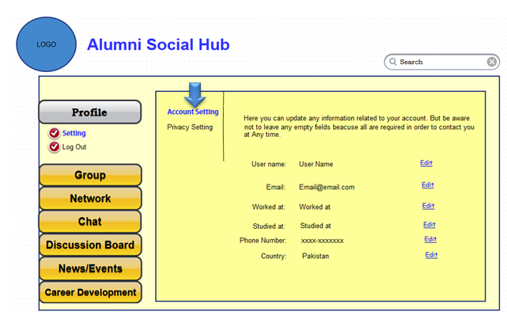

Description: This screen shows the admins’ home page containing options for profile setting. To change setting user shall select the ‘settings’ link and account details will be opened in editable mode.

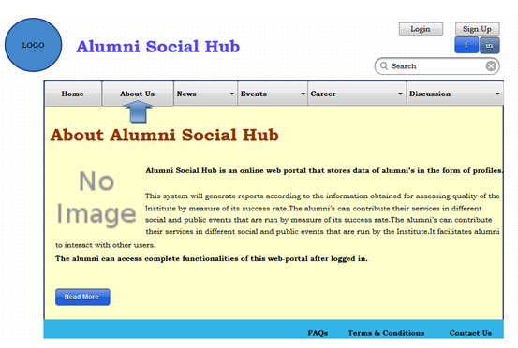

Description: This displays the home page of website with navigable links for ‘About us’, ‘News’.

**WBS and Gantt chart:**

A Work Breakdown Structure is a method of organizing and completing work in a project. With each increasing level, we increase the details. Basic structure is given in figure A-1, while detailed example is provided in Table A-1

Figure A-1 Basic Structure of WBS

Table A-1 – Example of a WBS for software development project

|  |  |  |  |  |
| --- | --- | --- | --- | --- |
| **ID** |  | **Task** | **Duration** | **Resources** |
| **1** | **Analysis** | | **8 d** | **Rita; William; Tyler; Wenger; Steve** |
| 2 |  | Requirement Meetings | 4 d | Rita; William |
| 3 |  | Communication with Stakeholders | 2 d | Rita; William; Tyler; Wenger; Steve |
| 4 |  | Document Current System | 2 d | William |
| 5 |  | Analysis Finished | 1 d |  |
| **6** | **Design** | | **18 d** | **Steve; Yvette; Zoe** |
| 7 |  | Design Database | 5 d | Steve |
| 8 |  | Software Design | 6 d | Yvette |
| 9 |  | Interface Design | 3 d | Zoe |
| 10 |  | Create Design Specifications | 7 d | Steve |
| 11 |  | Design Finished | 1 d |  |
| **12** | **Development** | | **22 d** | **Tyler; Wenger** |
| 13 |  | Develop System Module | 12 d | Tyler; Wenger |
| 14 |  | Integrate System Module | 7 d | Tyler |
| 15 |  | Perform Initial Testing | 3 d | Wenger |
| 16 |  | Development Finished | 1 d |  |
| **17** | **Testing** | | **17 d** | **Vicky; Mike** |
| 18 |  | Perform System Testing | 8 d | Vicky |
| 19 |  | Document Issues Found | 6 d | Mike |
| 20 |  | Correct Issues Found | 3 d | Mike |
| 21 |  | Testing Finished | 1 d |  |
| **22** | **Implementation** | | **15 d** | **Tyler; Mike** |
| 23 |  | On-Site Installation | 1 d | Tyler |
| 24 |  | Support Plan for the System | 15 d | Mike |
| **25** | **Completion** | | **9 d** | **Rita; William** |
| 26 |  | System Maintenance | 9 d | Rita |
| 27 |  | Evaluation | 9 d | William |

**WBS with Gantt Chart**